|  |  |
| --- | --- |
| Shipsmart user manual  By Software Chaser | Course: CSIT 515-01: Software engineering  Instructor: Dr. Hubert Johnson  Software chaser  Heba  Pragati  Sagina  Tej |
|  |  |

Contents

**1. Introduction** 1

**1.1 Purpose of the system** 1

**1.2 Project Goals** 1

**1.3 Purpose of the Current Document** 1

**2. How to lunch the System** 1

**3. User’s Manual** 3

**3.1 How to Navigate the System** 3

**3.1.1 Customer’s view pages** 3

**3.1.2 Admin’s view** 4

**4. Customer’s Manual** 4

**4.1 Sign Up** 4

**4.2 Log in** 4

**4.3 Create Shipment** 5

**4.4 Track shipment** 5

**4.5 Rates quote** 5

**4.6 About_US** 5

**4.7 Contact Us** 5

**5. Admin’s Manual** 5

**5.1 Orders** 5

**5.3 Create Shipment** 5

**5.4 Track Shipment** 5

**5.2 Warehouse Management** 5

**5.3 Billing** 5

**5.4 Claims** 5

**5.5 logout** 5

# 

# **1. Introduction**

## **1.1 Purpose of the system**

ShipSmart system is website which offers cross states shipping and international shipping as well. ShipSmart software will be an operation-management tool which will be built to meet industry-specific needs for domestic and cross-border logistics. ‘Software Chasers’ will develop a single system for the company to meet its operations, accounting, visibility and tracking, connectivity and compliance needs. It will also provide a solution to an end-to-end supply chain management for logistics.

## **1.2 Project Goals**

Software Chasers will develop a system that will help the PATCO Shipping company to manage the company’s shipping operation end to end. This system will help PATCO to attract new clients as well as maintain a good retention rate. The goal of Software Chasers is to create a software for the client.

## **1.3 Purpose of the Current Document**

This User Manual Document will guide ShipSmart System’s user through all ShipSmart System’s pages to insure a good user experience.

# **2. How to lunch the System**

In order to run the system on your desktop/laptop device, please follow the following steps:

1. Download XAMPP server to your device, its free and open-source cross-platform web server solution available for windows, OS X and Linux. to download it please click on this link <https://www.apachefriends.org/download.html>
2. Run XAMPP server and it will display the following screen as in Figure(1).

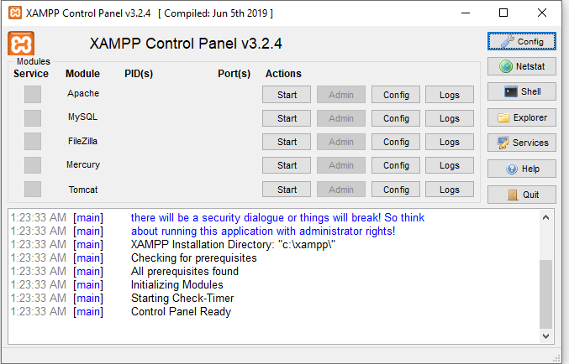

Figure 1: XAMPP Control Panel

1. Click on MySQL and Apache start Buttons. wait until you see green highlighted MySQL and Apache words. Then click on admin button for the MySQL as shown in Figure (2)

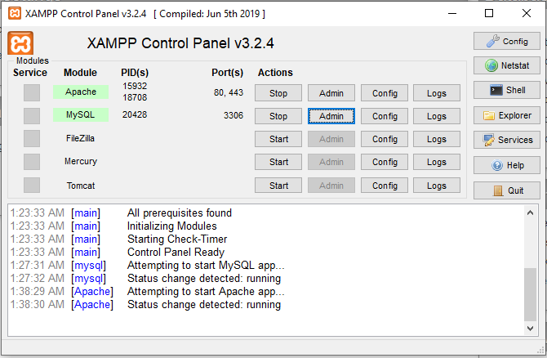

Figure : Run MySQL

1. Click on import tap on the navigation bar as shown in the below Figure (3).
2. Click on brows button and then select the shipsmart.sql file which included in the database file in ShipSmart Folder.

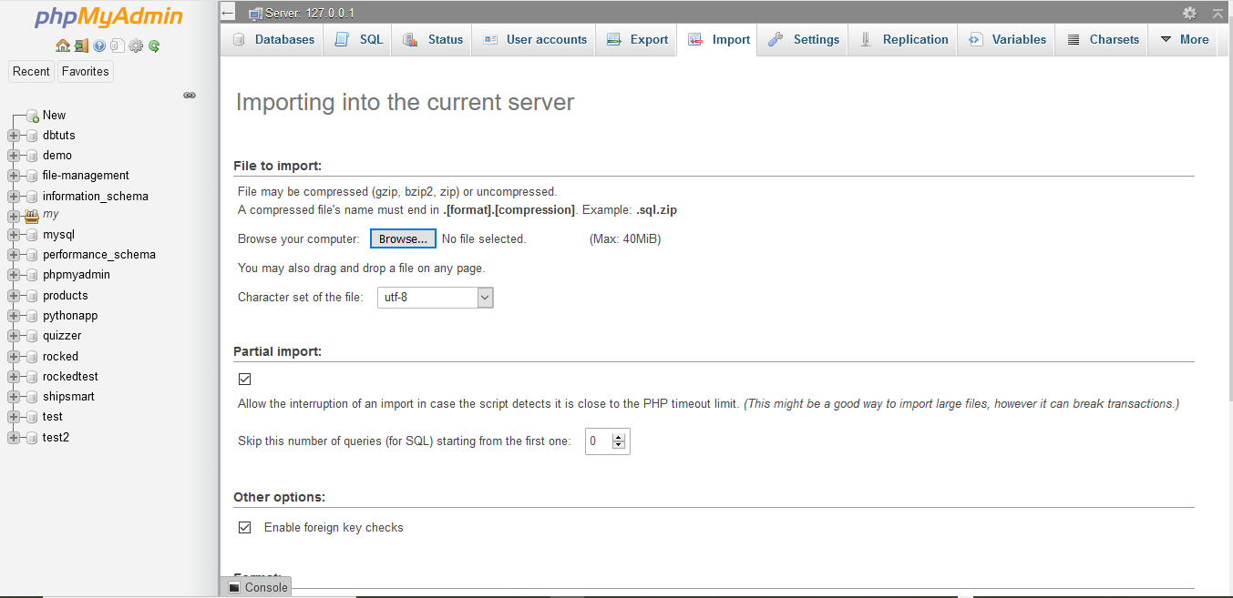

Figure 3: php MyAdmin page

1. Click on Go button. then you will receive a successful message tells you that you successfully has imported the database into your server.
2. In order to run the system source code, you need to download eclipse. Click on this link to download it <https://www.eclipse.org/downloads/>. Run eclipse software.
3. click on open project as shown in figure 4.
4. click on play button.

# **3. User’s Manual**

## **3.1 How to Navigate the System**

ShipSmart has two different views, one for the customer and one for the admin.

### **3.1.1 Customer’s view pages**

Customer are allows to login, signup, book a shipment, schedule pick up for the shipment, explore About_Us and Contact_Us pages. They also can track their shipment any time.

All customer’s pages have the same

1. Navigation bar on the top which allows user to do most of the activities mentioned above.
2. Page footer which includes links for PATCO’s social media platforms.

### **3.1.2 Admin’s view**

ShipSmart system’s admin has access to the main functions of ShipSmart system:

* Create Shipment.
* View all customers orders.
* Calculate Shipping prices.
* Track Shipments.
* View Billing and audit reports.
* Warehouse Management.
* Create Claims.
* Create Coupons and promo codes.

ShipSmart System has easy access admin dashboard which allow ShipSmart system’s admin to manage all of the above functions as shown in the following Figure.

# **4. Customer’s Manual**

## **4.1 Sign Up**

ShipSmart Software’s user can sign up for Patco clients company’s list by clicking on Sign up tab in the navigation bar as shown in figure

User need to enter his basic information as shown in figure

Pacto Company can add admins to ShipSmart system by clicking on sign up employee tab in the sign up page as shown in figure

## **4.2 Log in**

User needs to have an account with Patco to log in. If user has created account with Patco through ShipSmart Software then he can log in by clicking on log in tab in the main page and then enter user email address and password then click on log in button. If the user does not have an account with patco then the user need to sign up first.

login figure

## **4.3 Create Shipment**

## **4.4 Track shipment**

## **4.5 Rates quote**

## **4.6 About_US**

## **4.7 Contact Us**

# **5. Admin’s Manual**

## **5.1 Orders**

## **5.3 Create Shipment**

## **5.4 Track Shipment**

## **5.2 Warehouse Management**

## **5.3 Billing**

## **5.4 Claims**

## **5.5 logout**